WordPress Migration & Kiosk Deployment Guide

Part 1: Automated Script Actions
Part 2: Manual Post-Installation Steps
1. Finalize the WordPress Migration
2. Kiosk Mode & URL Configuration
3. Clean Up

WordPress Migration & Kiosk Deployment Guide
This guide covers the automated processes performed by the wordpress-db-restore2.sh script and the manual steps required to finalize the site migration and Kiosk mode setup.

Part 1: Automated Script Actions
The script handles the environment setup and data restoration to ensure the site is ready for local use without manual file transfers.
- WP-CLI Installation: Downloads and installs the WordPress Command Line Interface to allow for automated site management.
- Core Setup: Installs a fresh WordPress database at http://localhost with pre-defined admin credentials.
- All-in-One Migration Setup:
  - Installs and activates the standard All-in-One WP Migration plugin.
  - Downloads and installs the Unlimited Extension zip file from a secure S3 bucket to bypass default upload size limits.
- Backup Restoration: * Downloads the site backup file (cme-2024-v3.wpress) directly to the server.
  - Automatically triggers the ai1wm restore command to overwrite the clean install with the actual site data.
- System Configuration: * Sets directory permissions to www-data and 755 for security and stability.
  - Updates the database and sets the permalink structure to /%postname%/.

Part 2: Manual Post-Installation Steps
Once the script has finished executing, follow these steps to verify the site and activate Kiosk mode.

1. Finalize the WordPress Migration
- Login to Dashboard: Go to http://localhost/wp-admin/ in your browser.
  - Note: Use the credentials from the original site that was backed up, as the script's temporary credentials will have been replaced during restoration.
- Verify Permalinks: Go to Settings > Permalinks. Scroll to the bottom and click Save Changes. This is a critical step to ensure all internal links and pages resolve correctly.
- Check Plugins: Ensure both the "All-in-One WP Migration" and the "Unlimited Extension" are active in the Plugins menu.

2. Kiosk Mode & URL Configuration
To reflect the local WordPress site on the kiosk browser, you must update the system's configuration file.
- Edit the .cfg File: Locate the configuration file (e.g., kiosk.cfg or the system's browser startup script) used by your kiosk software.
- Update the URL: Set the primary startup URL to: http://localhost
- Verification: Restart the kiosk or the browser service. The browser should now automatically launch in a restricted, full-screen mode displaying your migrated WordPress site.

3. Clean Up
- Remove Installation Files: Once the site is verified, you can safely delete the .sh script and the .wpress file from the /wp-content/ai1wm-backups/ directory to save disk space.

Wordpress Offline deployment

Step 1:- Download the wordpress offline deployment script from below basecamp link
wordpress-offline-deploy2 (1).sh
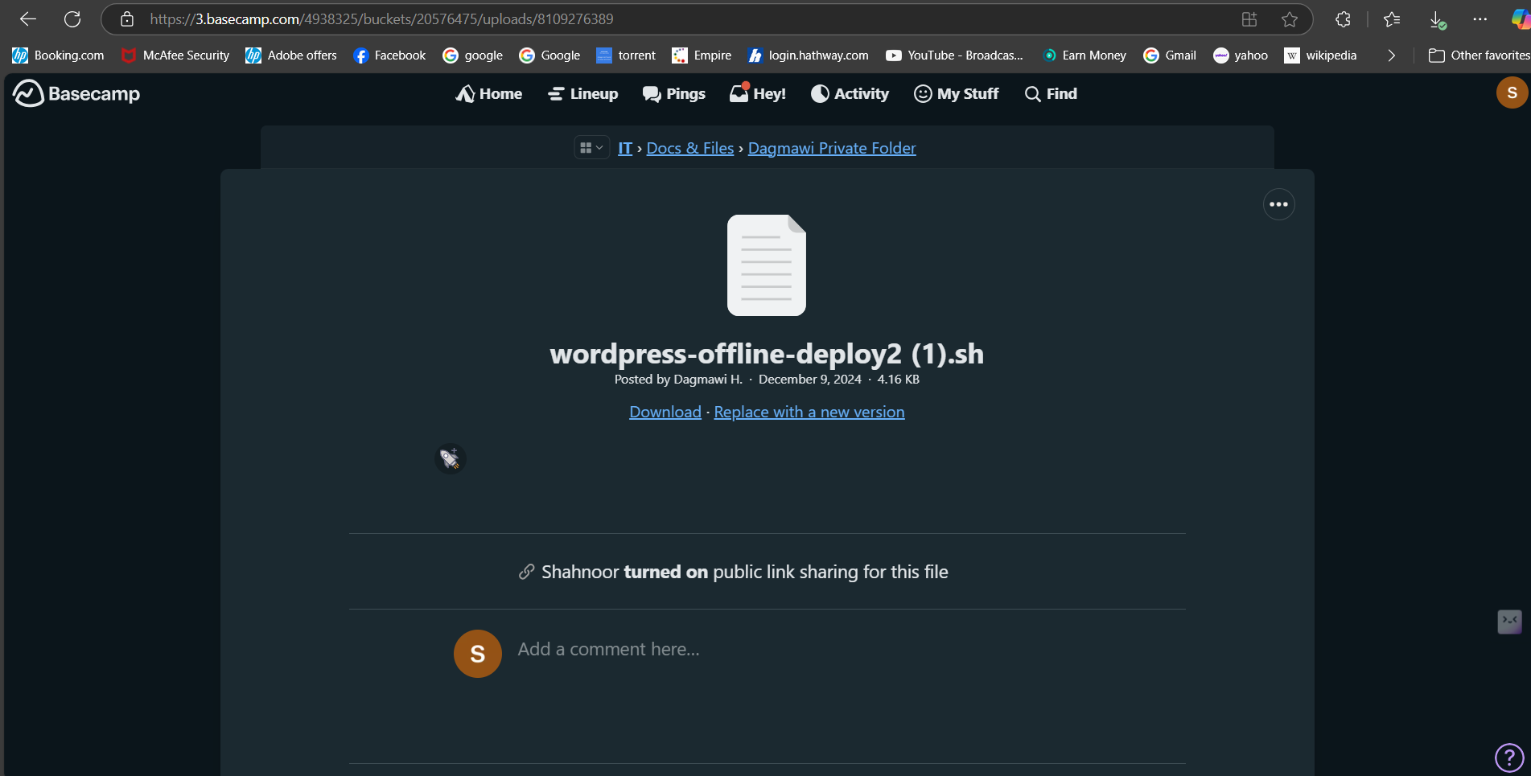
Step 2:- Transfer the script to the kiosk using meshcentral and execute below commands.
sudo chmod +x wordpress-offline-deploy.sh
sudo ./wordpress-offline-deploy.sh

Step 3:- Once the script is executed go to this URL http://localhost/wp-admin/ on browser login to wordpress.
username :- jolo@brandm3dia.com
password :- %DY@+^Q39a38Cse
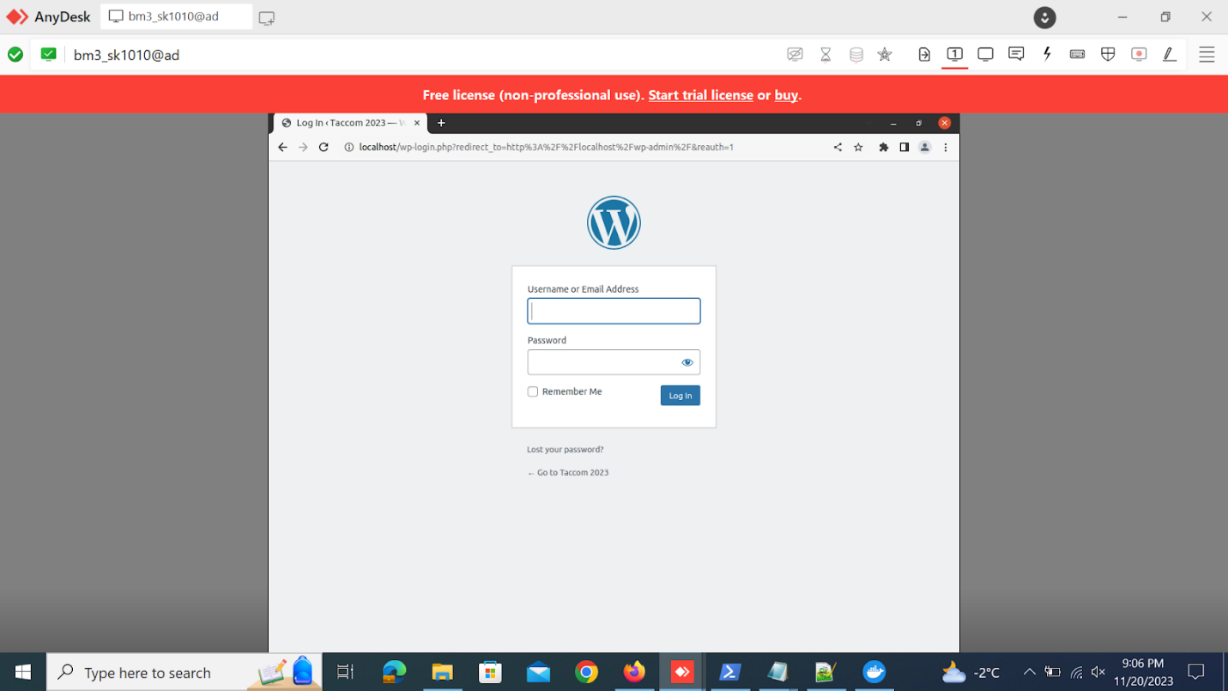
Step 4:- Go to Settings -> plug-ins and install WordPress all-in-one extension and unlimited extension plugin.
You can get unlimited extension from below link
https://bm3-wordpress-files.s3.ca-central-1.amazonaws.com/all-in-one-wp-migration-unlimited-extension.zip
Step 5:- Go to Settings -> plugins -> All in one Wordpress migration plugin and click on update.
Step 6:- Go to settings -> plugins -> Select All in one wordpress migration plugin and restore database from .wpress file.
Step 7:- Go to settings -> permalink -> scroll down and click on save.
